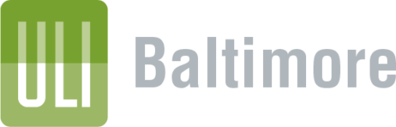
DEI Committee
West Baltimore Equitable Infrastructure Project
Public Comment Form 2022

Please complete form and submit via email to ghadeer.mansour@uli.org

Date:
Name:
Organization:
Address:
Email:
Phone:
Comments:

