City of Casa Grande
Downtown Mixed-Use Re-Development
Request for Interest
August 29, 2019

Prepared By
City of Casa Grande
510 E. Florence Blvd.
Casa Grande, AZ 85122

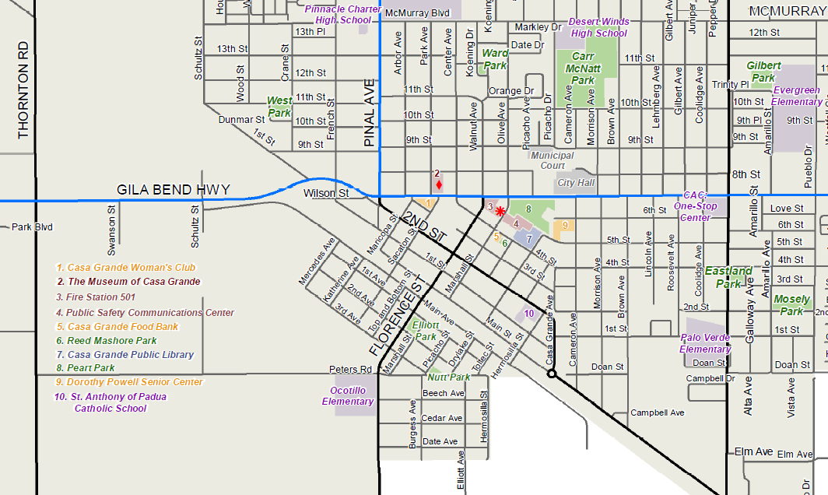
N
RFI Site Locations

Table of Contents
Request for Interest Cover Letter 3
Section I: Project Overview 4
Section II: Historic Preservation Ordinance, Public Policy and Neighborhood Goals 5
Section III: Development Program 5
Section IV: Site and Architectural Design Guidelines 6
Life on Main Master Plan 7
Opportunity Zones 7
Tax Incentives for Historic Preservation 7
Section V: RFI Submission Requirements 7
Section VI: Selection Process, Schedule and Criteria 9
Section VII: General Site Information 10
Section VIII: General RFI Conditions 11
Attachments 13
Attachment “A” – Site Aerial/General Plan/Zoning for 1.5 acre properties 13
Attachment “B” – Zoning/Parcel Numbers of 3.5 Acres 14
Attachment “C” – History of Historic Properties 15
Attachment “D” – General Plan 2020 Land Use Category 17
Attachment “E” – Excerpts from Life on Main Master Plan 20
Attachment “F” – Opportunity Zones Map 21

REQUEST FOR INTEREST
Downtown Mixed-Use Re-Development

Dear Sir/Madam:

The City of Casa Grande Arizona is now accepting expressions of interest for the acquisition and redevelopment of the properties located on W. Main Avenue from S. Katherine Street to S. Florence Street and between E. 2nd and E. 3rd Streets and Drylake and Toltec Streets in Downtown Casa Grande. The City will accept expressions of interest for mixed use developments, including retail, office, multi-family and business uses consistent with current zoning or a rezoning consistent with the General Plan. One of the City’s goals is to continue and accelerate the revitalization of its historic downtown and therefore stimulate further investment. The City’s vision for the project would include units for residential use and complimentary retail. However, if a developer or development team submits a plan with a scale that makes sense and is deemed to benefit the downtown area, it will be welcomed. This is being allowed in an effort to not stifle creative thought on the behalf of the developer or development team.

The City of Casa Grande currently owns the subject properties.

Please read the Request for Interest carefully, in that there are a number of policy goals that guide the redevelopment of the property.

There are several steps in order to complete this RFI. The first step is a letter of interest in the project and a summary of your firms experience in accomplishing the goals of these properties. Second, all letters of interest will be evaluated by a committee which they will develop a short list of the interested parties. Third, each interested party that is on the short list can schedule a pre-submission conference with the city. Fourth, the actual development plan proposal will be due roughly a month after the short list is developed. Fifth, proposal presentations will be given to the committee followed by selection committee recommendations. Finally, negotiations for a development agreement with the selected firm and approval at a city council meeting.

If you have any questions, please submit them in writing to Steven Weaver via email at Steven_Weaver@casagrandeaz.gov.

All letters of interest are due in City Hall, 510 E. Florence Blvd, Casa Grande, AZ 85122, no later than 5:00 P.M. on Tuesday, September 24, 2019.

Sincerely,

Steven M. Weaver
Steven M. Weaver
Deputy City Manager
City of Casa Grande

Section I: Project Overview

Introduction/Background
The City of Casa Grande is a fast-growing community of approximately 56,000 residents. The City of Casa Grande pro-business political climate is exemplified in the community’s commitment to investing in the future and the understanding that public investment must occur to ensure that an environment for quality private investment exists.

The City is averaging 60 new single-family permits per month since the beginning of this calendar year.

Project Overview
The City of Casa Grande is seeking an experienced developer or development team to purchase and build on sites located in the City of Casa Grande Downtown. There are nine parcels totaling approximately 3.5 acres located on W. Main Avenue from S. Katherine Street and S. Florence Street (See Attachment A). In addition there are 9 parcels that are approximately 1.5 acres that take up one city block with an alleyway and 8-inch sewer line down the middle. The city block is located between E. 2nd and E. 3rd and N. Drylake Street and N. Toltec Street (See Attachment B). The City’s vision for the development includes, but not be limited to: ground retail, institutional and office space, and medium to high density market rate apartments or condos.

The City owns all of the properties and would be available for purchase. There are two historic structures on parcels #507072410 (the Casa Grande Hotel) and #507072420 (Shonessy House). These buildings are listed on the local historic register as well as the National Register of Historic Places (See Attachment C).

The Casa Grande Hotel is a single story building that was originally a commercial building that was built in the early 1890’s. Initially, the building served railroad passenger traffic. From the 1930’s through 1961, the hotel’s restaurant and banquet room served monthly luncheons to the city’s civic organizations. Prominent Arizona residents, including Governor G.W.P. Hunt (1st Governor of Arizona) were frequent guests. The hotel, originally a five-room adobe rooming house was purchased in 1909. Over the next two years, eight more rooms were added, using adobe construction. Guests frequently slept on cots in the open air above the porch. In 1913, a two story concrete addition at the rear of the hotel was built, which is now bridged to the hotel by a third addition.

The Shonessy House is a single story adobe building that was built in 1890. One of the oldest adobe buildings in Casa Grande. The house is associated with William Shonessy, a businessman who arrived in Casa Grande around 1900 at the age of sixty-five. In 1913, he built one of town’s first reinforced cast-in-place concrete commercial buildings, which he leased to various businesses and doctors, next to his house.

The City would like a plan to incorporate these historic structures. Specifically there is an Adaptive Reuse component of the Historic Preservation Ordinance 1387.17.47 and a link to the ordinance in Section II.

Two of the nine parcels (#507130670 and #507072370) have been identified as having contaminants based on a Phase I Environmental (a copy can be obtained from the RFI contact person).

If the developer or development team designs a financially sound project with a different mix that is deemed to be beneficial to downtown development, it will be considers as the City in no way desires to limit professional and creative input.

Property Identification
The subject properties are approximately 5 acres of vacant and built-upon land. The properties are located along W. Main Avenue and a city block between E. 2nd and E. 3rd Streets in Casa Grande, AZ. The first parcel is located at 315 W. Main with the following properties just east down to Florence Street. All of these properties are located on the southern end of the historic downtown. They are close to the Union Pacific Railroad main line that runs from California to the East. They are walking distances from several downtown restaurants, grocery store, and other services. The subject properties are identified by the Pinal County Tax Assessor’s Office as parcel numbers: 507130670, 507072370, 507072380, 507072390, 507072400, 507072410, 507072420, 507072430, and 507072440.

The city block properties are located near our Main library campus. The subject properties are identified by the Pinal County Tax Assessor’s Office as parcel numbers: 507072070, 507072080, 507072090, 507072100, 507072110, 507072120, 507072130, 507072140, and 507072150. They are close to downtown businesses, restaurants, grocery store, neighborhood meat market, churches, and schools.

Section II: Historic Preservation Ordinance, Public Policy and Neighborhood Goals

Historic Preservation Ordinance 1387.17.47 https://casagrandeaz.gov/boards-and-commissions/historic-preservation-commission/
There are a number of public policy goals that guide the development of the subject site. These include:
Urban Land Institute Report https://ulidigitalmarketing.blob.core.windows.net/ulidcnc/2019/07/City-of-Casa-Grande-AzTAP-Report.pdf
Life on Main Master Plan http://downtowndevelopment.com/pdf/Life-On-Main-Mater-Plan_City-Council-2013-08-13_1%20(1).pdf
City of Casa Grande Strategic Plan https://drive.google.com/open?id=1YJeKbfpTfIWfr1k-mcSUhOU_1Hcd2EUW

Section III: Development Program

RFI Scope: The City of Casa Grande is seeking expressions of interest from qualified developers or development teams to purchase the properties, design, market and manage the property. Selected firms will be invited to submit plans for the entire site.
The City may provide some combination of the following to the winning proposal:
- Advantageous pricing for the acquisition of the land.
- Eligibility for New Markets Tax Credits financing.
- Wayfinding Signage to lead to subject property.

- Note: The City will not invest additional funds in the redevelopment of the property. The City is offering the site “As Is”.
Successful Developer will be expected to:
- Have ability to secure the financing for the acquisition and rehabilitation of the property.
- Secure all approvals, permits and pay fees necessary for development.
- Provide liability, builders risk and workman’s compensation insurance in amounts acceptable to the City of Casa Grande.
- Adhere to the agreed upon time schedule for construction. Construction shall be initiated within six (6) months of the real estate closing.
- Secure and maintain proof of appropriate licenses as required by local and state laws.
- Develop and execute a sales and marketing plan for the project.
- Provide on-site management or equivalent for entire existence of the apartments, if included.
- Provide a project development pro-forma and financial qualifications of the development team.
- Developers are encouraged to undertake their own due diligence prior to submission.

Section IV: Site and Architectural Design Guidelines

The design objective is to create a vibrant project that is attractive, easy to access and maintains and enhances the architectural character of the Downtown District.
The development must conform to requirements in the City Zoning Ordinance and the requirements set forth below:
- Zoning: The 1.5 acre city block property is zoned R-1 (Single-Family Residential). Rezoning may be required depending on use and the City is willing to initiate and change the zone in accordance with the General Plan (See Attachment D). The City believes B-3 is the best zone that provides a variety of uses such as residential to commercial.
  - The 3.5 acres of properties is currently zoned I-1 (Light Industrial). The site can be rezoned to multi-family residential or commercial, as these zoning categories are supported by the Community Center Land Use category.
- Unit Design: Project shall have a mix of retail, offices, institutional use, and medium to high density residential, unless it is demonstrated that other land use mixes are beneficial and feasible.
- Amenities: The project and site should be designed with amenities to support a desirable living and working environment and to include the two historical properties.
- Plans: Develop site and architectural plans including floor plans for proposed mixed-use facility for approval by the City.
- Construction: Maintain current building character and materials or equivalent. The nature of the area must be complimented where appropriate and required. Building heights should be limited to two above ground stories unless variance is granted.
- Utilities: Provide all utility connections to the site.
- On-site Parking: As required by City Zoning Code.
- Credits: Both sites may be eligible for New Market Tax Credits and the 3.5 acre parcels are located in an Opportunity Zone. There are tax incentives available for the historic properties.

Life on Main Master Plan
In the summer of 2012, the City engaged the planning firm Matrix Design Group to aid in the revitalization of certain area of downtown (See Attachment E). These properties incorporate a large portion of the Master Plan. The Life on Main area is part of the original Townsite of Casa Grande which was platted in 1890. The Casa Grande Townsite was laid out to follow the railroad line. The streets were laid out in a northwest-southwest orientation. The design is unique in Casa Grande, as it is the only area of town where the streets are laid out following the railroad line orientation.
This plan is a guiding document and is in no way a requirement for the applicant’s designs. However, it does provide an outline for the type of mixed-use design desired by the City. The Master Plan can be found on at: http://downtowndevelopment.com/pdf/Life-On-Main-Mater-Plan_City-Council-2013-08-13_1%20(1).pdf .

Opportunity Zones
The 3.5 acre parcels listed are qualified as an Opportunity Zone (See Attachment F), which means that investment in development of the site may, under certain conditions, be eligible for preferential tax treatment. The Opportunity Zones program is designed to spur economic development and job creation in distressed communities by providing tax benefits to investors. According to the Internal Revenue Services:
- Investors can defer tax on any prior gains invested in a Qualified Opportunity Fund (QOF) until the earlier of the date on which the investment in a QOF is sold or exchanged, or December 31, 2026. If the QOF investment is held for longer than five (5) years, there is a 10% exclusion of the deferred gain. If held for more than seven (7) years, the 10% becomes 15%.
- If the investor holds the investment in the Opportunity Fund for at least ten (10) years, the investor is eligible for an increase in basis of the QOF investment equal to its fair market value on the date that the QOF investment is sold or exchanged.
A Qualified Opportunity Fund is an investment vehicle that is set up as either a partnership or corporation for investing in eligible property that is located in a Qualified Opportunity Zone.

Tax Incentives for Historic Preservation
The Investment Tax Credit Program (ITC) permits owners and some lessees of historic buildings to take a 20 percent income tax credit on the cost of rehabilitating such buildings for industrial, commercial, or rental purposes. The link is under our website and can be found under: Documents/State Historic Property Tax Reclassification for Income Producing Properties. https://casagrandeaz.gov/boards-and-commissions/historic-preservation-commission/

Section V: RFI Submission Requirements

Developer Information
The letter of interest must respond to the following in the order stated below:
- A cover letter signed by the principal or Chief Operating Officer of the development entity committing to complete the project, if selected.
- A general description of the proposed project (rental, ownership or a combination thereof), including total number and type of units, development timelines, target markets, etc.
- Identification of all team members.
- A description of all team members’ experience and qualification for this project, particularly mixed use urban redevelopment projects with a mixed income component.
- Minimum of three references (name and telephone number) that can speak directly to the applicant development experience.
- Examples of relevant work
- Demonstrated ability to rehabilitate an adobe structure as well as historic buildings.
- Certificate of Good Standing from the Arizona Secretary of State or State where the developer/development team is incorporated.
After review of the letters of interest, selected developers will be required to submit three (3) bound copies of their proposal comprised of one signed original and two copies of the proposal at a later date. Applications must be submitted as follows:
- All pages are single-sided, pages are to be 8 ½” x 11”
- All pages are securely bound.
- Site plans, elevations and architectural rendering must be on pages no smaller than 11” x 17” paper.
- The applications package is to be arranged as outlined by sections below.
Proposed Project Information
- Economic development (i.e. retail) component
- Graphic illustrations of the conceptual design of the project, including:
  - Site plans and sections illustrating the relationship of the project to adjacent properties.
  - Ground floor plan and, floor plan for each unit type.
  - Elevations at the street and all sides including exterior finish materials.
Project Financing
- A financing plan that provides a project pro forma, a project budget, and additional sources of debt and equity for the project.
- A statement of the offered price for the land.
- Detail of the scope of work, specifications and cost estimate.
- A project schedule showing, at a minimum, start and ending dates for construction.
- A detailed management plan for the project’s management and operation.
- Proposed sources and uses of funds.
- A minimum three (3) year cash flow projection.
Developer Information
- Applicant’s (Lead Developer) financial statements prepared by an accountant for current year and previous year.
- Most recent independent audit.
- Auditor’s management letter.
- Applicant’s (Lead Developer) organization/background information
- Legal name of business.
- Director/President of the organization.
- Articles of Incorporation and current bylaws.
- IRS 501(c)(3) determination letter (if non-profit)
- Type of organization, (Corporation, General Partnership, Limited Liability Corporation, etc.)
- List of Board of Directors (include address and telephone numbers).
- Current organizational chart.
- Federal Tax ID# or Social Security # of owners.

Section VI: Selection Process, Schedule and Criteria

Selection Process: The Selection Committee will be composed of City of Casa Grande staff. The Selection Committee will review all letters of interest, and invite selected firms to submit a proposal. After reviewing proposals, staff will recommend a developer for City of Casa Grande City Council approval. A short list of developers (three or four) may be selected for an interview with the Selection Committee as a part of the process.
Schedule: The preliminary schedule for this project follows:
- Issue of Request for Interest: August 29, 2019
- Letter of Interest Due Date: September 24, 2019
- Selection Committee Reviews and Short List: September 27, 2019
- Pre-Submission Conference: As scheduled by interested parties
Location: Casa Grande City Hall
510 E. Florence Blvd.
- Development Plan Proposal Due Date: October 28, 2019
- Proposal Presentations (if required): November 4-6, 2019
- Selection Committee Recommendation: November 16, 2019
- Development Agreement Negotiations: November 17-December 13, 2019
- City Council Approval: January 6, 2020
The City of Casa Grande reserves the right to adjust the schedule at its sole discretion.
RFI Selection Criteria: The City of Casa Grande will select the solicit proposals from the developer/development teams that most successfully meets the criteria listed below:
- Ability to meet City development goals
- Proven ability of the development team to successfully develop and manage similar projects.
- Provide a narrative statement of intent and development proposal based off the City plan and vision for the different properties addressing the following:
  - Expected mix of land uses and end-users
  - Any anticipated partnerships or end-uses whom Offeror may intend to include in the development.
  - Expected square feet of development (including FAR).
  - How the proposed plan supports the City’s plans.
  - Project phasing of:
    - Infrastructure
    - Vertical development
    - Horizontal development
  - How the site would be positioned in the market and Offeror’s strategy for selection of tenants.
  - A construction mitigation plan that identified potential challenges that neighboring businesses and residents may experience during the development and operating periods.
  - Conceptual Site Plan showing anticipated land uses and densities.
- Demonstrated ability to rehabilitate an adobe structure as well as a historic building.
- Proposed Term Sheet that addresses each of the following items:
  - Purchase price, including breakdown of purchase price by phase if phasing is proposed.
  - Phasing/Takedown Schedule (if/as applicable).
  - Proposed earnest money
  - Closing Dates
- How does Offeror propose to fund the project? Include the following:
  - Proposed type of funding source(s). Offeror shall propose a clear strategy to fund all proposed development costs.
  - Sources of and costs of debt and equity, including specific details on all anticipated funding sources as well as the types and amounts of equity, financing, grants and other funding sources for the proposed development.
- Commitment and ability to bring developer equity to the project.
- Quality of design proposed and ability of the development team to implement a high qualify project.
- Consideration of a development plan that complements and bolsters the existing artistic and historic character of the area. Concepts could include but are not limited to: an architectural design the complements the surrounding area.
This RFI is not a request for competitive proposals and is not subject to the Arizona Public Contracting Code. This RFI in no way obligates the City to enter into a relationship with any entity that responds to this RFI or limits or restricts the City’s right to enter into a relationship with any entity that does not respond to this RFI. In its sole discretion, the City may pursue discussions with one or more entities responding to this RFI or none at all.

Section VII: General Site Information

- Property and Location: Developed and undeveloped properties in downtown Casa Grande on W. Main Avenue from S. Katherine Street and S. Florence Street.
- Tax Map Reference: 507130670, 507072370, 507072380, 507072390, 507072400, 507072410, 507072420, 507072430, and 507072440.
- Fee-Simple Owner: City of Casa Grande
- Zoning: Light Industrial: (I-1)
- Land area: 3.5 acres +/-
- Electricity: APS
- Water: Arizona Water Company
- Protection: City of Casa Grande Police and Fire Departments
- Sanitary Sewer Line: City of Casa Grande
- Telephone: CenturyLink
- Traffic Count: Main Ave ADT – 970; Florence Street ADT – 3,100
- Accessibility/Directions: The site is located on W. Main Avenue within walking distance to downtown. This site is accessible from Florence Blvd.
- Topography: Some of the sites are partially developed. Site is primarily flat.
- Zoning and Other Restrictions: A copy of the City’s zoning ordinance can be obtained from the City of Casa Grande Planning Department or online. In addition, the Planning Department staff will be available to review preliminary site plans for zoning consistency during the RFI process. Site plan reviewing by the Planning Staff will be completed within five (5) working days.

- Property and Location: City Block properties (undeveloped) in downtown Casa Grande on E. 2nd St and E 3rd Street and N. Drylake and N. Toltec Street.
- Tax Map Reference: 507072070, 507072080, 507072090, 507072100, 507072110, 507072120, 507072130, 507072140, and 507072150.
- Fee-Simple Owner: City of Casa Grande
- Zoning: Single-Family Residential: (R-1)
- Land area: 1.5 acres +/-
- Electricity: APS
- Water: Arizona Water Company
- Protection: City of Casa Grande Police and Fire Departments
- Sanitary Sewer Line: City of Casa Grande
- Telephone: CenturyLink
- Traffic Count: 2nd Street ADT – 5,000
- Accessibility/Directions: The site is within walking distance to downtown. This site is accessible from Florence Blvd.
- Topography: Undeveloped. Site is primarily flat.
- Zoning and Other Restrictions: A copy of the City’s zoning ordinance can be obtained from the City of Casa Grande Planning Department or online. In addition, the Planning Department staff will be available to review preliminary site plans for zoning consistency during the RFI process. Site plan reviewing by the Planning Staff will be completed within five (5) working days.

Section VIII: General RFI Conditions

Post Selection Agreements: After City Council approval, the City intends to enter into a contract with the selected developer within 10 days. This contract will summarize the agreed upon terms and conditions of the project. The Development Agreement will at a minimum, address the following issues:
- Purchase Price
- Timelines for project
- Roles and responsibilities of the Developer and City.
- Assurances and security guarantees of performance.
- Penalties for non-performance.
- Terms and conditions outlined in this RFI, as applicable.
- City’s rights to review and approve the design of the project.
- City’s rights to review and approve management changes.
Proposal Reservations: The City reserves the right to reject any or all letters of interest, to award in whole or part and to waive minor immaterial defects in letters of interest. The City may consider any alternative proposal that meets its basic needs.
Changes/Alterations: Proposer may change or withdraw proposal at any time prior to proposal deadline; however, no oral modifications will be allowed. Only letters, or other formal written requests for modifications or corrections of a previously submitted proposal, which is addressed in the same manner as the proposal, and received by the City prior to the scheduled closing time for receipt of letters of interest, will be accepted. The proposal, when opened will then be corrected in accordance which such written request(s), provided that the written request is contained in a sealed envelope plainly marked “modifications of proposal.”
Confidentially: Responses to the RFI will become public records and, therefore, will be subject to public disclosure.
Proposer Questions, Inquiries and Contact with City Officials and Staff: The City is committed to providing all interested parties with accurate and consistent information in order to ensure that no one obtains an undue competitive advantage. To this end all questions and inquiries should be addressed in writing to:
Proposal and Technical Questions:
Subject: Mixed-Use RFI
Steven_Weaver@casagrandeaz.gov

As this request for information only, this RFI may lead to one of five outcomes:
- A request for additional information from one or more RFI respondents.
- The issuance of a Request for Proposal (RFP) to one or more responders chosen as part of this RFI.
- The issuance of a RFP is opened to all potential development teams.
- Direct negotiations for sale and redevelopment of the properties through a MOU or DDA with a development team(s) selected as a result of this RFI.
- Termination of this process without the selection of a development team or issuance of an RFP.

If the answer or information sought is of procedural or substantive significance, the City will provide the answer or information in writing to all prospective proposers.

Attachment “A” – Site Aerial/General Plan/Zoning for 1.5 acre properties
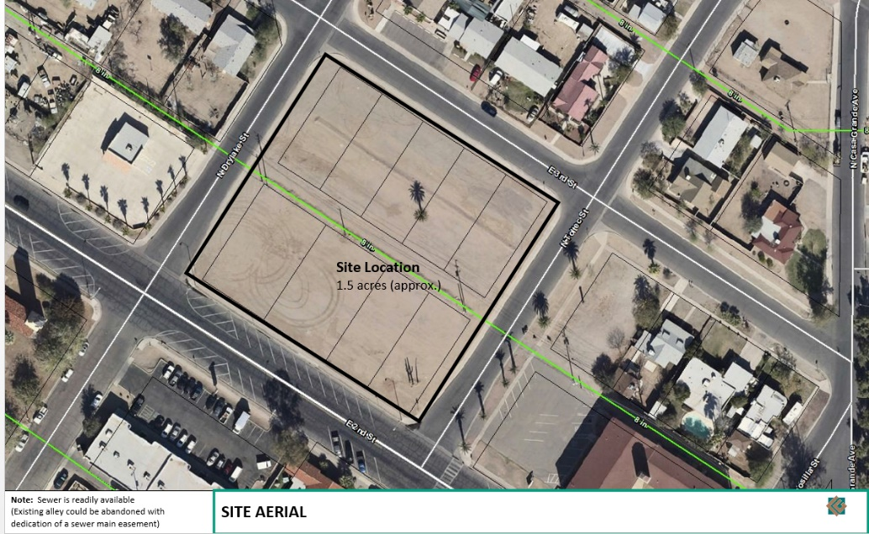

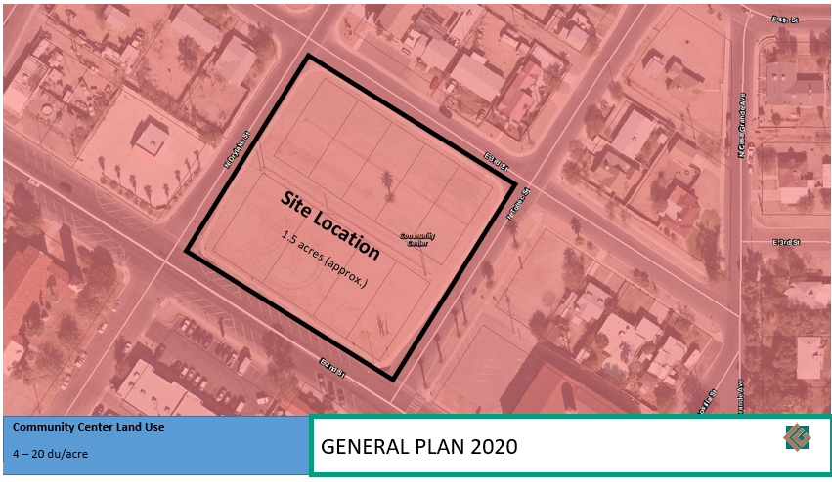

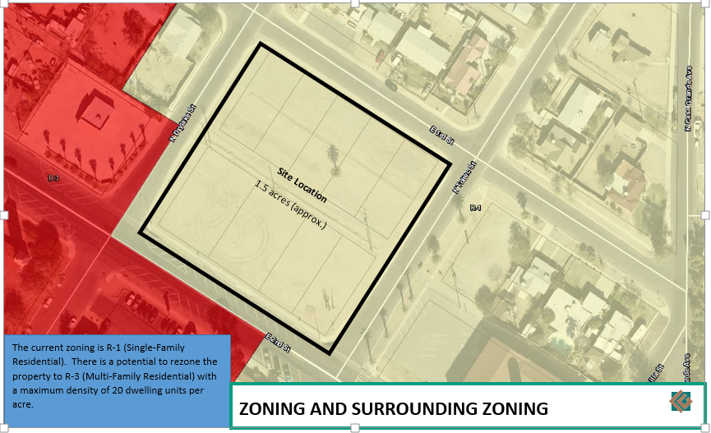

Attachment “B” – Zoning/Parcel Numbers of 3.5 Acres
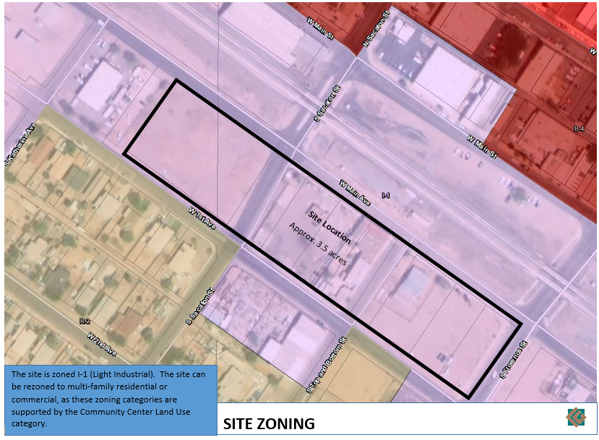

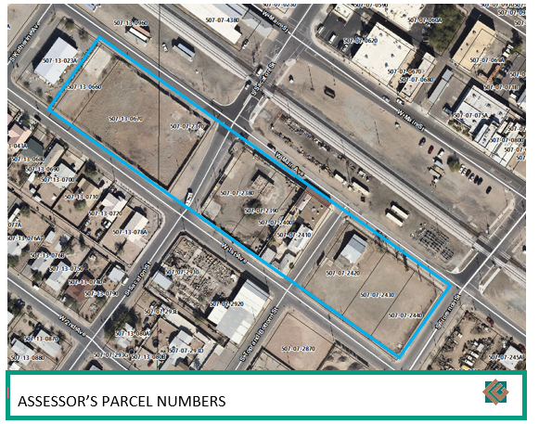

Attachment “C” – History of Historic Properties
The Life on Main area houses a couple of historic buildings: the Casa Grande Hotel and the Shonessy House. These buildings are listed on the local historic register as well as the National Register of Historic Places.
The Casa Grande Hotel is a single story building that was originally a commercial building that was built in the early 1890’s. Initially, the building served as railroad passenger traffic. From the 1930’s through 1961, the hotel’s restaurant and banquet room served monthly luncheons to the city’s civic organizations. Prominent Arizona residents, including Governor G. W. P. Hunt (1st Governor in Arizona) were frequent guests. The hotel was also noted for its fine restaurant.
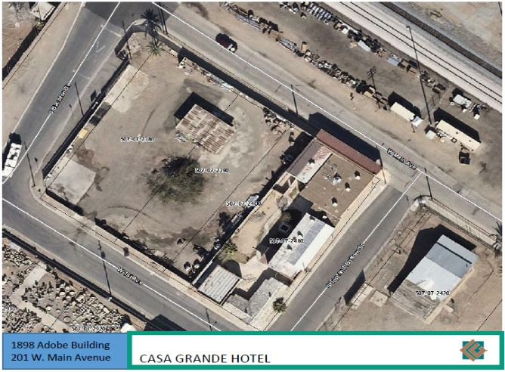
The hotel, originally a five-room adobe rooming house was purchased in 1909 by William Gould, a local rancher. Over the next two years, Gould added eight more rooms, using adobe construction. Guest’s frequently slept on cots in the open air above the porch. In 1913 Gould built a two-story, concrete addition at the rear of the hotel, which is now bridged to the hotel by a third addition. Gould died in 1916, and the hotel was operated by his daughter until 1961. The exterior was modified with Mission Revival details. 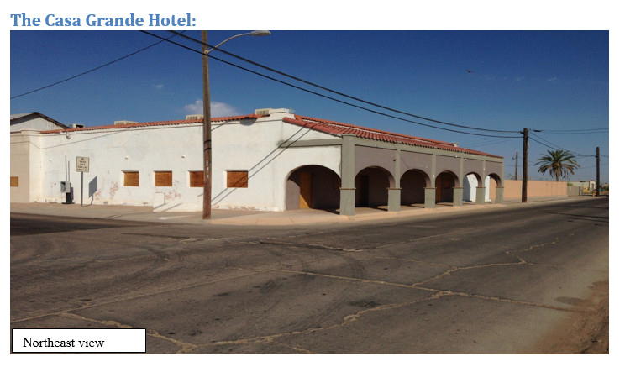
The Shonessy House is a single story adobe building that was built in 1890. One of the oldest adobe buildings in Casa Grande. The house is associated with William Shonessy, a businessman who arrived in Casa Grande around 1900 at the age of sixty-five. In 1913, he built one of the town’s first reinforced cast-in-place concrete commercial buildings, which he leased to various businesses and doctors, next to his house. Shonessy left Casa Grande for California for health reasons in 1919 and died there in 1922. The house is also associated with the family of Don Chun Wo, who occupied the house between 1933 and 1943. Don Chun Wo operated the commercial building next door as a grocery store from 1927 to 1943 and was a highly respected businessman.
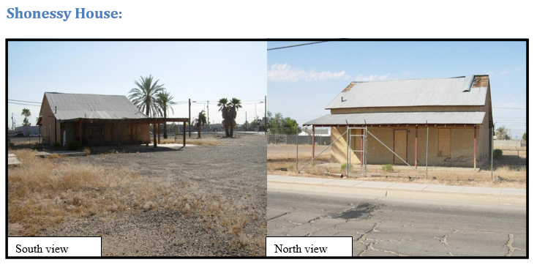
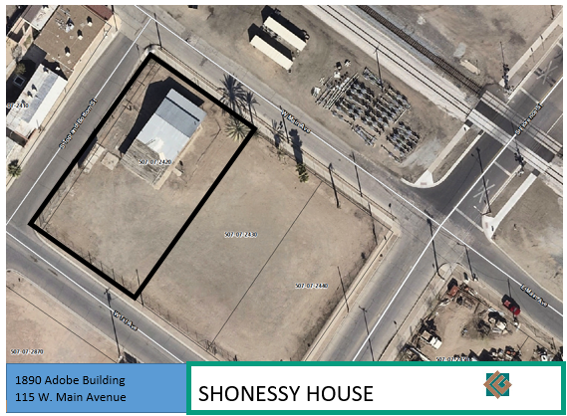

Attachment “D” – General Plan 2020 Land Use Category
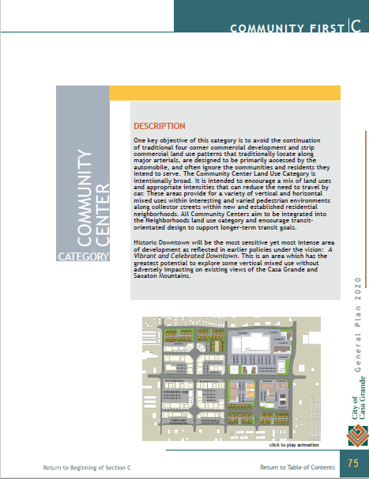

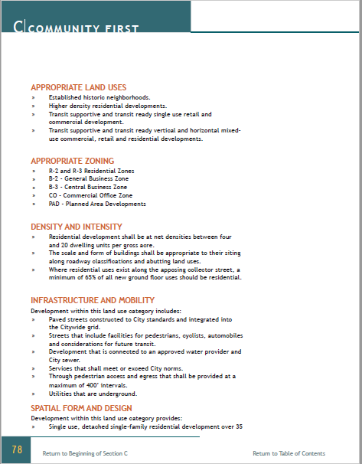

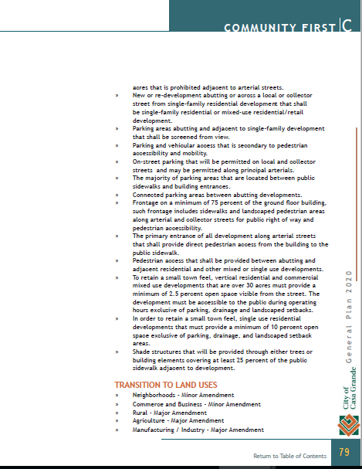

Attachment “E” – Excerpts from Life on Main Master Plan
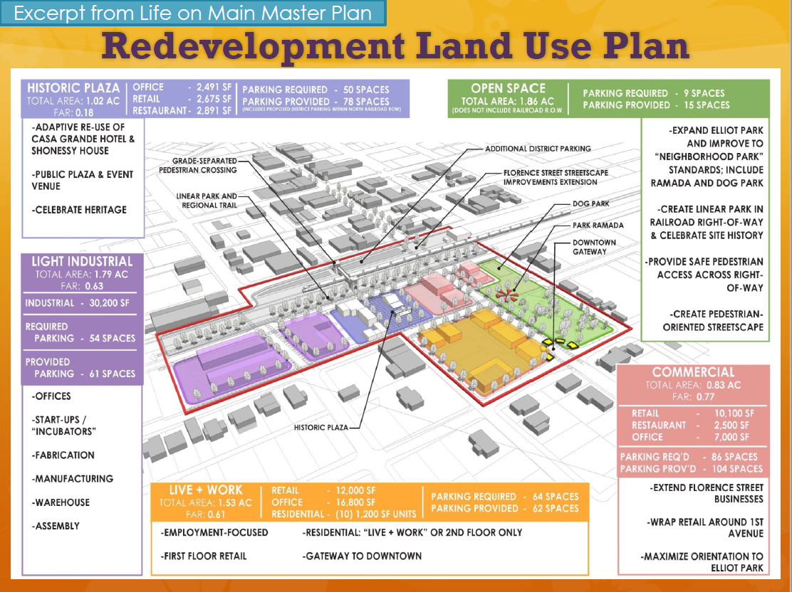

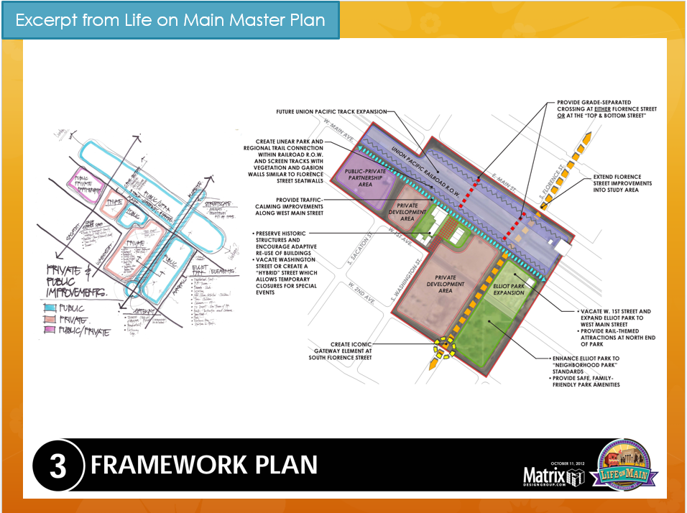

Attachment “F” – Opportunity Zones Map
